FIGMA:
ONLINE BUS BOOKING

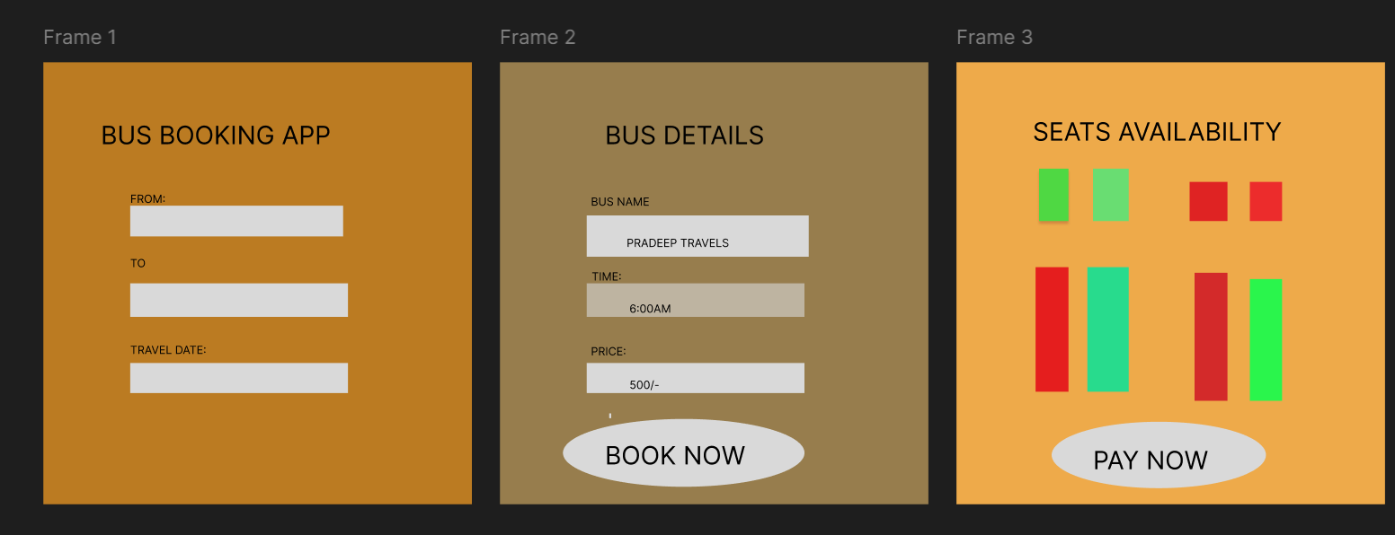

ONLINE SHOPPING

